**Async JavaScript: Promises & Callbacks**

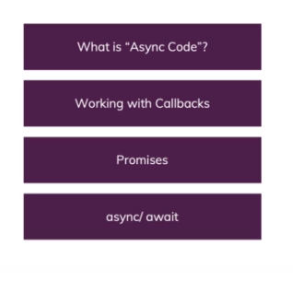

**Understanding Synchronous Code Execution ("Sync Code")**

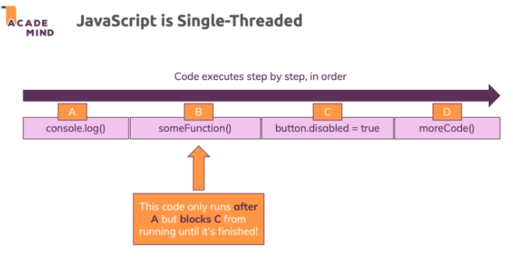

**Understanding Asynchronous Code Execution ("Async Code")**

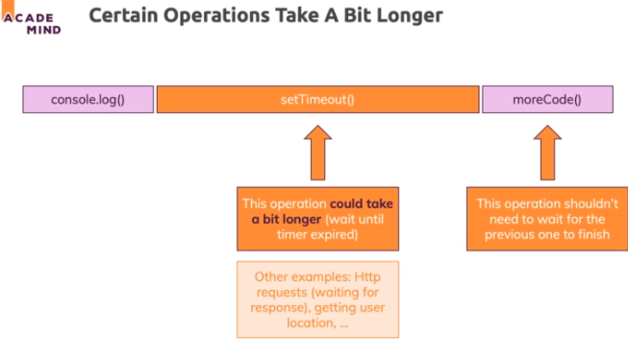

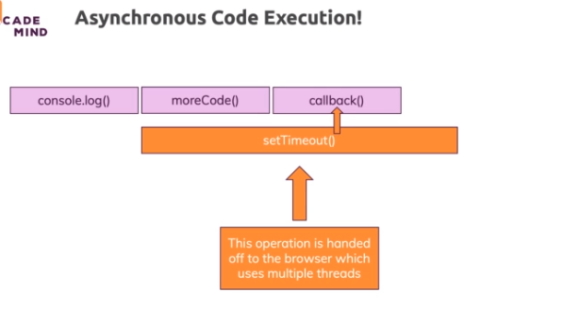

**Blocking Code & The "Event Loop”**